Our Onancock Marina Staff will be happy to answer any questions you may have regarding the Tangier Island Ferry. Please be sure to read this list of Frequently Asked Questions & if you have any other questions, feel free to ask our staff.
- SEASON BEGINS - The ferry will start running on the following date:
  - First weekend in May
SEASON ENDS - The ferry will suspend scheduled runs on the following date:
  - First weekend in October
- RESERVATIONS:
  - We encourage you to make a reservation.
  - The Harbormaster Staff has brochures on-hand, with information on the Ferry.
  - The Harbormaster Staff CANNOT make a reservation for you.
  - Please contact Captain Mark Crocket or his wife Joyce @ (757) 891-2505
- HOW OFTEN DOES THE FERRY RUN BETWEEN ONANCOCK & TANGIER ISLAND:
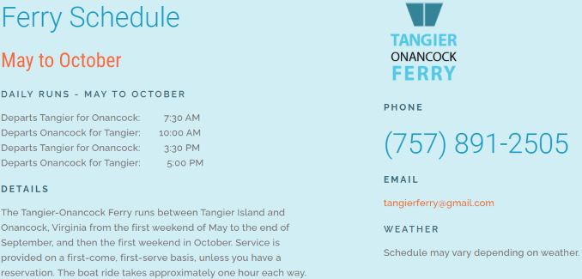
- COST & HOW TO PAY:
  - $25 round-trip overnight $30 round trip
  - Payments are made to Captain Mark Crockett
  - We do not process payments through the Harbormaster Office
- WHERE DO WE MEET THE FERRY IN ONANCOCK:
  - The Ferry will come into Onancock in Slip #11
  - You DO NOT have to check-in at the Harbormaster Office, instead, please check-in with the Ferry Captain directly at slip #11.

